**Master Page:**

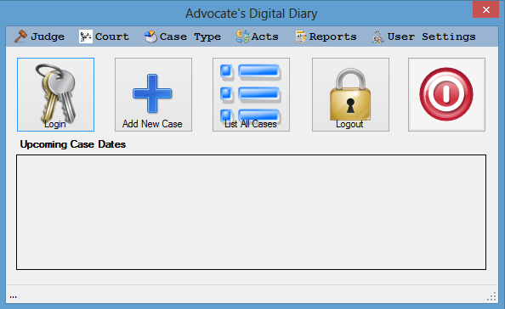

* This is the home page (master page) of Advocates Digital Diary which will help the users to access to the software and check all the details.
* In the Master page there are six tabs for Judge, Court, Case Type, Acts, Reports and User Settings.
* In Judge, Court, Case Type and Acts there are two menu items like Add and List All through users can add new item and can view the list.
* In Reports Tab there are six menu items like Judges, Courts, Case, Acts and Case Types through which users can view the lists of Judges, Courts, Cases, Acts and Case Types.
* In User Settings tab there are three menu items like Add User, User List and Database Configuration.
* Master page contains five buttons for Log In, Add New Case, List All Cases, Log Out and Exit.
* Master page also contains one data grid view to show the list of upcoming case dates